MYSQL Practical

Create below tables and also add required primaary key, foreign key and constraints in it.
- User,
- Product,
- Order (with User ID, Order status and expected delivery date)
- Order detail (order id, product Ids)
1. Fetch all the User order list and include atleast following details in that.
- Customer name
- Product names
- Order Date
- Expected delivery date (in days, i.e. within X days)
2. Create summary report which provide information about
- All undelivered Orders
- 5 Most recent orders
- Top 5 active users (Users having most number of orders)
- Inactive users (Users who hasn’t done any order)
- Top 5 Most purchased products
- Most expensive and most chepest orders.

- Creating Database:

CREATE DATABASE db_practical;

- Using Database:

USE db_practical;

- Creating USER Table:

CREATE TABLE user (
`userid` INT(11) PRIMARY KEY NOT NULL,
`name` VARCHAR(20) NOT NULL,
`contact` INT(10) NOT NULL,
`address` VARCHAR(50),
`gender` CHAR(2) NOT NULL,
`nationality` VARCHAR(50)
);

- Adding Auto-increment to primary Key

ALTER TABLE `db_practical`.`user`
CHANGE COLUMN `userid` `userid` INT NOT NULL AUTO_INCREMENT ,
ADD UNIQUE INDEX `userid_UNIQUE` (`userid` ASC) VISIBLE;

- Inserting Data:

INSERT INTO `user` (`name`,`contact`,`address`,`gender`,`nationality`) VALUES('Abhishek',1234567,'Mahidharpura Surat 395003','M','Indian') ;

INSERT INTO `user`(`name`,`contact`,`address`,
`gender`,`nationality`) VALUES('Kishan',567890,'Kutch','M','Indian'),
('Heema',152637,'Ahemadabad','F','Indian'),
('Sunny',938271,'Torento','M','Cannadian'),
('Chintan',834679,'Belgium','M','Europian');

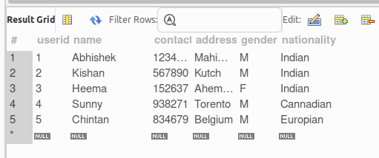

- Creating PRODUCT Table:

CREATE TABLE product (
`productid` INT PRIMARY KEY NOT NULL
AUTO_INCREMENT UNIQUE,
`product_name` VARCHAR(20) NOT NULL,
`manufacturerid` INT NOT NULL,
`price` FLOAT DEFAULT 0.0,
`quantity` INT DEFAULT 0,
`weight` FLOAT DEFAULT 0,
FOREIGN KEY (manufacturerid) REFERENCES user(userid)
ON UPDATE CASCADE
ON DELETE CASCADE
);

- Inserting Data:

INSERT INTO `product` (`product_name`,`manufacturerid`,`price`,`quantity`,
`weight`) VALUES('ONE PLUS Nord CE 2',4,26500.00,10,3.75);

INSERT INTO `product` (`product_name`,`manufacturerid`,`price`,`quantity`,
`weight`) VALUES('ONE PLUS Nord 3',4,20500.00,15,3.50),
('Samsung Smart TV',3,90499.00,25,20.50),
('Apple Air Pods',5,56450.55,30,2.10),
('Apple I-Phone 14',5,95463.55,15,4.10),
('Samsung Z-Fold',3,50000.00,6,3.57);
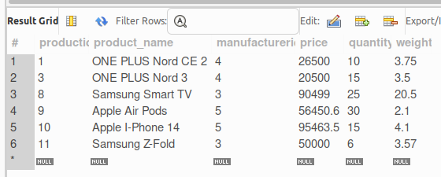

- Creating ORDER Table:

CREATE TABLE `order` (
`orderid` INT PRIMARY KEY NOT NULL
AUTO_INCREMENT UNIQUE,
`userid` INT NOT NULL,
`order_status` VARCHAR(25) DEFAULT "Pending",
`order_date` DATE NOT NULL,
`expected_delivery` DATE NOT NULL,
`quantity` INT DEFAULT 0,
FOREIGN KEY (userid) REFERENCES user(userid)
ON UPDATE CASCADE
ON DELETE CASCADE
);

- Inserting Data:

INSERT INTO `order`(`userid`,`order_status`,`order_date`,
`expected_delivery`,`quantity`) VALUES (1,'Accepted',
'2022-04-16','2022-04-17',1);

INSERT INTO `order`(`userid`,`order_status`,`order_date`,
`expected_delivery`,`quantity`)
VALUES (2,'Delivered','2023-01-16','2023-01-16',2),
(1,'Pending','2022-12-30','2023-01-01',1),
(2,'Declined','2022-12-25','2022-12-26',1),
(3,'Delivered','2023-01-30','2023-01-30',5),
(3,'Delivered','2023-01-30','2023-01-30',1);

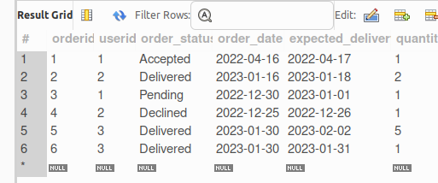

- Creating ORDER_DETAILS Table:

CREATE TABLE `order_details` (
`orderid` INT NOT NULL REFERENCES `order`(orderid)
ON UPDATE CASCADE
ON DELETE CASCADE,
`productid` INT NOT NULL REFERENCES `product`(productid)
ON UPDATE CASCADE
ON DELETE CASCADE,
`trans_status` VARCHAR(30) DEFAULT 'Pending',
`delivery_date` DATE);

- Inserting Data:

INSERT INTO `order_details` (`orderid`,`productid`,`trans_status`,`delivery_date`)
VALUES (1,1,"Done",NULL),
(2,1,"Done","2023-01-18"),
(5,3,"Done","2023-01-30"),
(6,4,"Done","2023-02-01"),
(3,3,"Pending",NULL);

INSERT INTO order_details(orderid,productid,trans_status) VALUES(4,9,"Done");

- Adding Amount Column

ALTER TABLE `db_practical`.`order_details`
ADD COLUMN `amount` BIGINT NULL DEFAULT 0 AFTER `delivery_date`;

- Update amount column

UPDATE order_details SET amount = (SELECT p.price*o.quantity FROM `order` o , `product` p WHERE o.orderid=1 AND p.productid=1) WHERE orderid = 1;
UPDATE order_details SET amount = (SELECT p.price*o.quantity FROM `order` o , `product` p WHERE o.orderid=2 AND p.productid=1) WHERE orderid = 2;

UPDATE order_details SET amount = (SELECT p.price*o.quantity FROM `order` o , `product` p WHERE o.orderid=5 AND p.productid=3) WHERE orderid = 5;

UPDATE order_details SET amount = (SELECT p.price*o.quantity FROM `order` o , `product` p WHERE o.orderid=6 AND p.productid=8) WHERE orderid = 6;

UPDATE order_details SET amount = (SELECT p.price*o.quantity FROM `order` o , `product` p WHERE o.orderid=3 AND p.productid=3) WHERE orderid = 3;

UPDATE order_details SET amount = (SELECT p.price*o.quantity FROM `order` o , `product` p WHERE o.orderid=4 AND p.productid=9) WHERE orderid = 4;

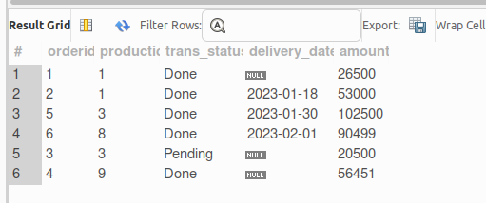

- MySQL PRACTICAL QUERY:

1) Fetch all the User order list and include atleast following details in that.
- Customer name
- Product names
- Order Date
- Expected delivery date (in days, i.e. within X days)

SELECT u.name AS "Customer Name", p.product_name AS "Product Name", o.order_date AS "Order Date",
CONCAT(DATEDIFF(o.expected_delivery,o.order_date)," days") AS "Expected Delivery"
FROM `order_details` od
LEFT JOIN `order` o USING(`orderid`)
LEFT JOIN `product` p USING(productid)
LEFT JOIN `user` u USING(userid)
WHERE delivery_date IS NOT NULL
ORDER BY o.order_date;

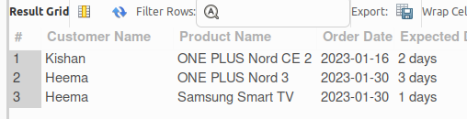

2. Create summary report which provide information about
- All undelivered Orders

SELECT * FROM `order` WHERE NOT order_status = "Delivered";

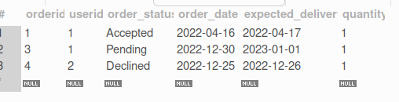

- 5 Most recent orders

SELECT * FROM `order` ORDER BY orderid DESC LIMIT 5;

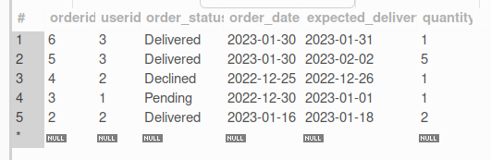

- Top 5 active users (Users having most number of orders)

OPTION 1:

SELECT u.name AS "Active Users", count(o.quantity)
AS "No. Of Orders"
FROM `order` o
INNER JOIN `user` u USING(userid)
GROUP BY u.name
ORDER BY count(o.quantity) DESC LIMIT 5;
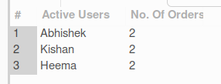

- Inactive users (Users who hasn’t done any order)

SELECT usr.name AS "Inactive Users" FROM `user` usr
WHERE usr.userid NOT IN (
SELECT DISTINCT o.userid
FROM `order` o INNER JOIN `user` u USING(userid)
);

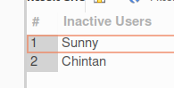

- Top 5 Most purchased products

SELECT p.product_name AS "Most Purchased Products", count(o.quantity) AS "Total Quantity"
FROM `order_details` od
INNER JOIN `product` p USING(productid)
INNER JOIN `order` o USING(orderid)
GROUP BY p.product_name
ORDER BY count(o.quantity) DESC LIMIT 5;

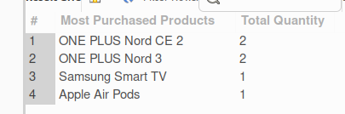

- Most expensive and most chepest orders.

SELECT max(output.total) AS "Most Expensive Order", min(output.total) AS "Most Chepest Order" FROM (
SELECT p.price*o.quantity AS total FROM `order_details` od
INNER JOIN `order` o USING(orderid)
INNER JOIN `product` p USING(productid)
) AS output;

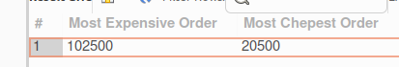

OPTION 2:

WITH main AS (SELECT p.product_name AS pname, p.price as price, o.quantity as quantity
FROM `order_details` od
INNER JOIN `order` o USING(orderid)
INNER JOIN `product` p USING(productid))
SELECT @total as "Total Amount", main.pname, "Most Chepest" AS "Order Status"
FROM main WHERE (@total:= main.price*main.quantity) = (
SELECT MIN(main.price*main.quantity) AS min
FROM main)
UNION
SELECT @total as "Total Amount", main.pname, "Most Expensive" AS "Order Status"
FROM main WHERE (@total:= main.price*main.quantity) = (
SELECT MAX(main.price*main.quantity) AS max
FROM main);

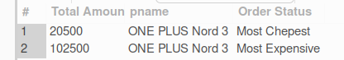

OPTION 3:

SELECT p.product_name as "Product", od.amount as "AMOUNT", "Most Expensive" AS "Status"
FROM `order_details` od INNER JOIN product p USING(productid) WHERE od.amount = (
SELECT MAX(odr.amount) FROM `order_details` odr)
UNION
SELECT p.product_name as "Product", od.amount as "AMOUNT", "Most Chepest" AS "Status"
FROM `order_details` od INNER JOIN product p USING(productid) WHERE od.amount = (
SELECT MIN(odr.amount) FROM `order_details` odr);



